 | Industrias GALARZA, S. A.  Pol. Ind. Bildosola, Pab. D-4 - E-48142 Artea - SPAIN  Tel. + 34 - 94 - 447 18 12 / 447 18 16  Fax + 34 - 94 - 476 42 76
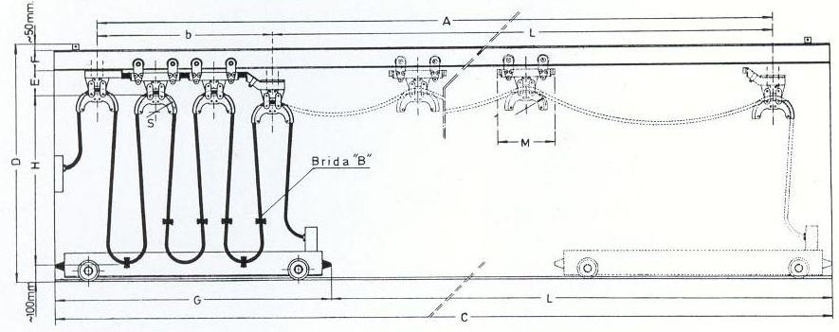 |  | To : ....................................  Attn. : ................................
PLEASE , FILL IN ENCLOSED QUESTIONNAIRE
Ref. ......................................
1 ) Type of application/industry where the festoon system is going to be installed.....................................
.........................................................................................................................................................
2 ) Travelling length : L = .......................... m
3 ) Maximum loop heigth : H = ......................... m
4 ) Maximum ambush length : b = .......................... m
5 ) Can be ambush length increassed ? No / Yes, in .................. m
6 ) Traverse speed : v = ........................... m/min
7 ) Acceleration : a = ........................... m/sec²
8 ) Daily duty (hours). Running factor ..............................................................................................
9 ) Ambient conditions :  Outdoor /  Indoor
Temperature conditions : ........... ºC min .......... ºC max
Special conditions : ...............................................................
..................................................................................
10 ) Type of beam : IPN........... IPE........... Others (Please send sketch)
11 ) Conductors :
Quantity of  cables | Type of cable | Number of cores and nominal cross section | Overall diameter | Weight / m
Quantity of  cables | Type of cable | Number of cores and nominal cross section | Width x thickness | Weight / m
12 ) For curved tracks, please, submit an sketch .
13 ) Additional information which might be relevant for the selection of the trolleys : ...................................
.........................................................................................................................................................
REGARDS
INDUSTRIAS GALARZA, S.A.

