 | Industrias GALARZA, S. A.  Pol. Ind. Bildosola, Pab. D-4 - E-48142 Artea - SPAIN  Tel. + 34 - 94 - 447 18 12 / 447 18 16  Fax + 34 - 94 - 476 42 76
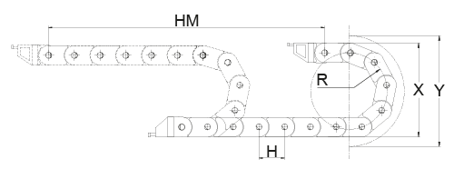 |  | Company name :  .................................  For the attention of. :  ................................
PLEASE FILL OUT THIS QUESTIONNAIRE
Ref. ......................................
1 ) Type of application/industry where the energy chain is to be installed............................................
.........................................................................................................................................................
2 ) Total displacement of the machine: L = .......................... m
3 ) Feeding point:  Extreme /  Center
4 ) Movement :  Horizontal /  Vertical
5 ) Velocity of displacement : v = ........................... m/min
6 ) Acceleration : a = ........................... m/seg²
7 ) Duty factor: ……… mov / h ……….. days / year
8 ) Environmental conditions:  Interior /  Exterior
 Normal  Dust  Humidity
 Corrosive elements: ……………………………………..  ATEX : ………………..………………………………………

Temperature conditions: ........ ºC min ....... ºC max
9 ) Electric cables :
Amount of  cables | Number of threads and section | External diameter  ( mm ) | Weight  ( Kg / m ) | Minimum radius of curvature ( mm )
10 ) Additional information that could be important for chain selection: ......................................................
.........................................................................................................................................................
11 ) If there was already a cable chain before: Manufacturer name: …………………………….……..
Model / Type of chain: ……………...………………….

